 |  | ST. ANDREW’S JUNIOR COLLEGE  Higher 1  PRELIMINARY EXAMINATION 2010
Name |  |  |  |  |  |  | Class
CHEMISTRY  PAPER 1 |  |  |  |  |  |  | 8872/ 01  21 September 2010  50 minutes
Additional Materials: |  |  | Multiple Choice Answer Sheet  Data Booklet
READ THESE INSTRUCTIONS FIRST
Sections A and B (30 marks)
There are thirty questions in these sections. Answer all questions. For each question there are four possible answers A, B, C, and D.
Choose the one you consider correct and record your choice in soft pencil on the separate Answer Sheet.

Each correct answer will score one mark. A mark will not be deducted for a wrong answer.

This paper consists of 10 printed pages.
Section A (25 marks)
For each question there are four possible answers, A, B, C and D. Choose the one you consider to be correct.

1. | Which statement about 44 g of CO₂ is correct?
 | A | It contains the same number of atoms as 14 g of ¹⁴N.
 | B | It contains twice the number of atoms as 16 g of ¹⁶O₂.
 | C | It contains the same number of molecules as 14 g of ¹⁴N₂.
 | D | It contains the same number of molecules as 32 g of ¹⁶O₂.

2. | 15 cm³ of an unknown hydrocarbon was burnt completely in 200 cm³ of excess oxygen. The volume of gases in the final mixture was 170 cm³. After passing the gaseous products through an alkaline solution, the volume decreased by 60 cm³. Given that all volumes were measured at room temperature and pressure, what is the formula of the hydrocarbon?
 | A | C₄H₈ | B | C₄H₁₀
 | C | C₅H₁₀ | D | C₅H₁₂

3. | Vanadium, V, in ammonium vanadate(V), NH₄VO₃, can be reduced to a few oxidation states with zinc metal. A 200 cm³ solution of 0.05 mol dm⁻³ ammonium vanadate(V) required 0.327 g of zinc metal to react completely. Given that zinc is oxidised to Zn²⁺, what is the final oxidation state of vanadium in the product?
 | A | +1 | B | +2
 | C | +3 | D | +4

4. | Which of the following reactions is a disproportionation reaction?
 | A | Fe₂O₃ + 3CO → 2Fe + 3CO₂
 | B | 2CrO₄²⁻ + 2H⁺ → Cr₂O₇²⁻ + H₂O
 | C | 2H₂O₂ → 2H₂O + O₂
 | D | 2H₂S + 3O₂ → 2H₂O + 2SO₂

5. | Which of the following pairs consists of a planar and non-planar molecule?
 | A | NO₃⁻, C₃H₈ | B | XeF₄, CO₃²⁻
 | C | NH₄⁺, ClO₃⁻ | D | C₂H₄, H₂O

6. | Aluminium fluoride has a melting point of 1291 °C while aluminium chloride sublimes at 178 °C. Which of the following statements accounts for this difference?
 | A | Aluminium ion has a high charge density.
 | B | The intermolecular interactions between aluminium fluoride molecules are stronger than that between aluminium chloride molecules.
 | C | Al – F bond is stronger than Al – Cl bond.
 | D | Fluoride ion has a smaller electron cloud than chloride ion.

7. | The graph below shows the second ionisation energies (in kJ mol⁻¹) of 8 consecutive elements, A to H, whose atomic numbers are less than 20.  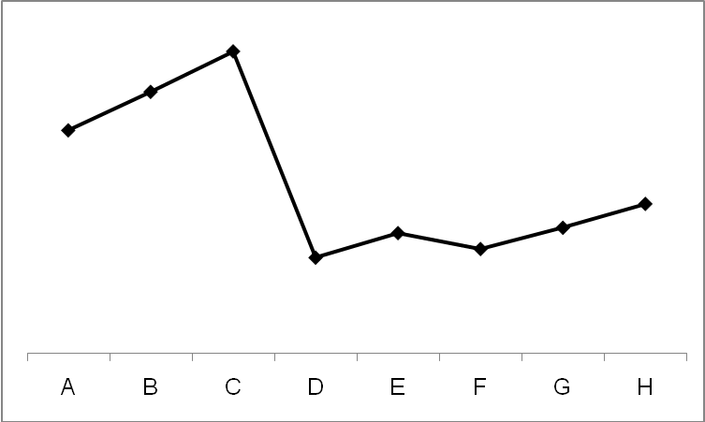  What is the formula of the compound formed between A and D?
 | A | D₂A | B | DA₂
 | C | D₃A | D | DA

8. |  | Alpha particles, He²⁺, are commonly emitted by larger radioactive nuclei. A mixture of an unknown ion, X, O²⁺ and alpha particles are passed through an electric field, as shown in the diagram below.  source  alpha particle  O²⁺  X  Which of the following represents X?
 |  | A | Li⁺ |  | B | Be²⁺
 |  | C | B³⁺ |  | D | Al³⁺
9. |  | A study of the kinetics of the decomposition reaction of an unknown sample, Y, was conducted and the following data was obtained.  Which of the following graphs is correct?
  [Y] / mol dm⁻³ | Relative initial rate
  0.5 | 1
  1.0 | 1
  1.5 | 1
A | time  [Y] |  |  | B |  |  | time  [Y]
C | time  [Y] |  |  | D |  |  | time  [Y]

10. | Use of the Data Booklet is relevant to this question.  When 8.00 g of ammonium nitrate, NH₄NO₃, was added to a polystyrene cup containing 100 cm³ of water, the temperature of the water changed from 25 °C to  15 °C. What is the enthalpy change of reaction of ammonium nitrate dissolving in water?
 | A | - 4.18 kJmol⁻¹
 | B | - 41.8 kJmol⁻¹
 | C | + 4.18 kJmol⁻¹
 | D | + 41.8 kJmol⁻¹

11. | Lattice energy of an ionic salt XY is more exothermic than MgO. Which of the following about the ionic radii of X and Y and the charges of their ions is correct when compared with that of magnesium and oxygen?
 |  | Ionic radius |  | Charge of ions
 |  | X | Y | X | Y
 | A | Same | Same | Lower | Lower
 | B | Smaller | Smaller | Same | Same
 | C | Larger | Larger | Same | Same
 | D | Larger | Larger | Lower | Lower

12. | The value of the enthalpy change for the process represented by the equation:  O₂(g) + 4e⁻ 2O²⁻(g) is equal to
 | A | the sum of the first and second electron affinity of oxygen
 | B | the sum of the enthalpy change of atomisation and the first electron affinity of oxygen
 | C | the sum of the enthalpy change of atomisation, first and second electron affinity of oxygen
 | D | twice the sum of the enthalpy change of atomisation, first and second electron affinity of oxygen

13. | An equilibrium is represented by the following equation:  2SO₂ (g) + O₂ (g) 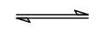 2SO₃ (g) Δ H = − a kJ mol⁻¹  Which of the following changes would affect both the percentage yield of sulphur trioxide and the value of the equilibrium constant?
 | A | Adding vanadium(V) oxide as the catalyst
 | B | Decreasing the temperature
 | C | Increasing the mass of sulphur dioxide
 | D | Reducing the pressure

14. | Silver chloride dissolves in dilute ammonia to form a silver(I) diamine complex and the equilibrium equation is shown below.  AgCl(s) + 2NH₃(aq)Ag(NH₃)₂⁺(aq) + Cl⁻(aq)  What are the units for the equilibrium constant?
 | A | mol dm⁻³ | B | no units
 | C | mol⁻¹ dm³ | D | mol⁻² dm⁶

15. | What is the pH of a 0.20 mol dm⁻³ aqueous solution of methylamine, CH₃NH₂, at 25°C? Given that K_{b} = 5.0 x 10⁻⁴ mol dm⁻³.
 | A | 2.0 | B | 10.0
 | C | 12.0 | D | 16.0

16. | Which of the following mixtures is not a buffer solution?
 | A | 25 cm³ of 0.05 mol dm⁻³ HCl mixed with 25 cm³ of 0.1 mol dm⁻³ CH₃COONa
 | B | 25 cm³ of 0.1 mol dm⁻³ NaOH mixed with 25 cm³ of 0.05 mol dm⁻³ CH₃COOH
 | C | 25 cm³ of 0.05 mol dm⁻³ HCl mixed with 25 cm³ of 0.1 mol dm⁻³ NH₃
 | D | 25 cm³ of 0.1 mol dm⁻³ NH₄Cl mixed with 25 cm³ of 0.2 mol dm⁻³ NH₃

17. | Which salt is produced from a strong acid and a strong base?
 | A | CH₃COONa
 | B | NH₄NO₃
 | C | NaHCO₃
 | D | NaHSO₄

18. | Element L, found in period 3, forms an oxide which is insoluble in water but dissolves in both HCl and NaOH. What is the pH of a solution of its chloride?
 | A | 3
 | B | 6
 | C | 7
 | D | 9

19. |  | Which graph shows the trend in electrical conductivity across Period 3 elements?
A  Elements  Electrical conductivity  Na Mg Al Si P O Cl Ar |  |  | B  Elements  Electrical conductivity  Na Mg Al Si P O Cl Ar
C | Elements  Electrical conductivity  Na Mg Al Si P O Cl Ar |  | D | Elements  Electrical conductivity  Na Mg Al Si P O Cl Ar

20. | Which structure correctly represents 4-chloro-3-hydroxybutanoic acid?
 | A | 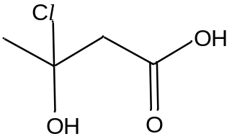 | B | 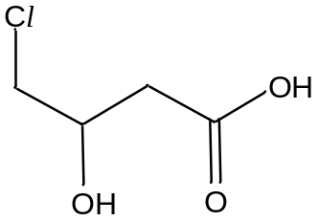
 | C | 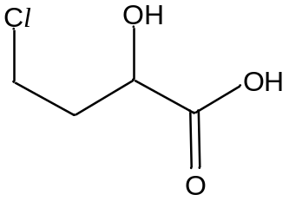 | D | 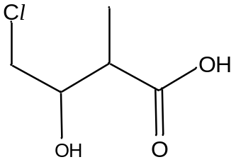

21. | Propanal, CH₃CH₂CHO, reacts with HCN in a nucleophilic addition reaction. What is the hybridisation state of the carbon bonded to the nitrile (-CN) group in the product?
 | A | sp | B | sp²
 | C | sp³ | D | no hybridisation present

22. | Which of the following organic compounds will most likely undergo a nucleophilic substitution reaction by OH⁻ to give an alcohol?
 | A | chloroethane
 | B | chlorobenzene
 | C | 2-bromomethylbenzene
 | D | 2-butene

23. | A series of tests was carried out on Compound X and the following observations were recorded in the table below.  What could Compound X be?
  Tests / Reagents & Conditions | Observations
  Alkaline aqueous iodine, Heat | Yellow ppt observed with a medicinal smell detected
  Acidified KMnO₄, Heat | Purple KMnO₄ decolourised
 | A | CH₃CHO | B | CH₃CH₂CH(CH₃)COCH₃
 | C | CH₃CH₂C(CH₃)₂OH | D | C₆H₅CH(CH₃)CH₂OH

24. | Which carbon atom in the molecule shown will readily be attacked by an electrophile?  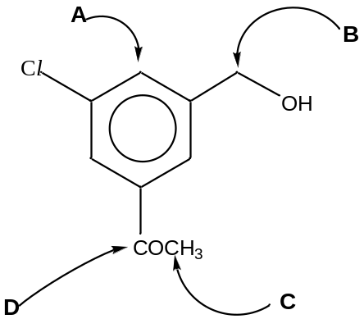

25. | Which of the following is the most suitable reagent for the conversion reaction below?  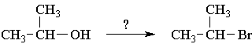
 | A | NaBr | B | SOBr₂
 | C | Br₂ | D | AlBr₃
Section B (5 marks)
For each of the questions in this section one or more of the three numbered statements 1 to 3 may be correct. Decide whether each of the statements is or is not correct (you may find it helpful to put a tick against the statements which you consider to be correct).

The responses A to D should be selected on the basis of
A | B | C | D
1,2 and 3 are correct | 1 and 2 only are correct | 2 and 3 only are correct | 1 only is correct

No other combination of statements is used as a correct response.

26. | Which of the following statements can be explained by hydrogen bonding?
 | 1 | Butan-1-ol has a higher boiling point than 2-methylpropan-1-ol.
 | 2 | Carboxylic acids often form dimers in the gaseous state.
 | 3 | A clogged water pipe is likely to burst during winter.

27. | 3-chloropropene is heated with aqueous NaOH to form CH₂(OH)CH = CH₂. The kinetics of this reaction are given below.  Which of the following statements are correct?
  Experiment No. | [3-chloropropene]  / mol dm⁻³ | [NaOH]  / mol dm⁻³ | Initial rate  / mol dm⁻³ s⁻¹
  1 | 0.01 | 0.02 | 1.4 x 10⁻³
  2 | 0.01 | 0.03 | 1.4 x 10⁻³
  3 | 0.04 | 0.20 | 5.6 x 10⁻³
 | 1 | Rate = k [3-chloropropene]
 | 2 | The units of rate constant are mol⁻¹ dm³ s⁻¹.
 | 3 | The overall order of reaction is 2.

28. | Which of the following reagents can be used to distinguish the following two compounds?  C₆H₅CHO CH₃CH₂COOH
 | 1 | Tollen’s reagent
 | 2 | Aqueous sodium carbonate
 | 3 | Sodium metal
The responses A to D should be selected on the basis of
A | B | C | D
1,2 and 3 are correct | 1 and 2 only are correct | 2 and 3 only are correct | 1 only is correct

No other combination of statements is used as a correct response.

29. | A compound has the structural formula shown below.  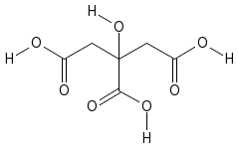  How can it be classified?
 | 1 | An ester
 | 2 | A carboxylic acid
 | 3 | An alcohol

30. | Which of the following compounds gives  (i) white ppt with cold ethanolic silver nitrate;  (ii) fumes of HCl with PCl₅?
 | 1 | 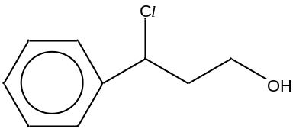
 | 2 | 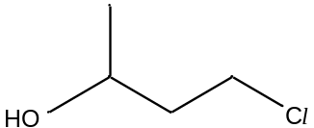
 | 3 | 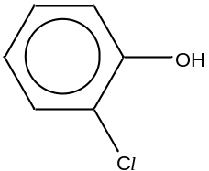

*******************END OF PAPER********************

